

COMP 8347

Internet Applications and Distributed Systems

Lab 6

Submitted to: Dr. Adel Abusitta

July 2nd , 2023

*Submitted By:*

*Hamza Baig (110089314)*

*Harsimran Singh (110090200)*

*Vivek Verma (110094354)*

*Talha Muhammad Shamoon Chaudhry (110087321)*

*Vidya Sehgal (110090510)*

*Komalben Kishorbhai Patel (110091595)*

*Abhishek Singh (110089745)*

Table of Contents

Part 1 Base Template and CSS: 3

A – Create static folder and add style.css file to it: 3

B - Also create base.html in templates: 4

C – Update homepage, aboutus, cardetail with base.html: 4

Part 2: 6

A – Update Vehicle model and add features field: 6

B – Forms.py: 6

C – Views for forms: 7

# Part 1 Base Template and CSS:

## A – Create static folder and add style.css file to it:

## B - Also create base.html in templates:

## C – Update homepage, aboutus, cardetail with base.html:

# Part 2:

## A – Update Vehicle model and add features field:

## B – Forms.py:

Forms.py:

## C – Views for forms:

Views.py:

Vehicles.html:

Orders.html

CarUrls.py:



Urls.py:

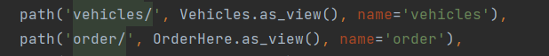

Base.html:

